**Compute adaptive weight for ANN (by hand)**

Given the initial weights:

w1j w1i w2j w2i w3j w3i wjk wik

0.2 0.1 0.3 -0.1 -0.1 0.2 0.1 0.5

Input: [1, 0.4, 0.7]

Nodes:

(1,2,3) -> (j,i) -> k

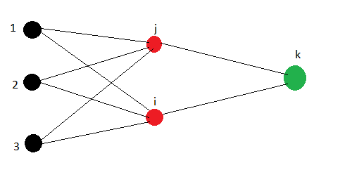

Calculate the updated weights for the first iteration:

oj = w1jx1j+ w2jx2j + w3jx3j = 1*0.2 + 0.3*0.4 + (-0.1)*0.7 = 0.25

oi = w1ix1i+ w2ix2i + w3ix3i = 1*0.1 + 1.3*(-0.1) + 0.2*0.7 = 0.2

ok = wjkxj+ wikxj = wjkoj + wikoi = 0.1*0.25 + 0.5*0.2 = 0.125

δk = ok (1 – ok )(tk – ok ) = 0.125(1 – 0.125)(tk – 0.125).

δj = oj(1 – oj)∑kwjkδk = 0.25(1-0.25)0.1*δk = 0.01875δk

δi = oj(1 – oi)∑kwikδk = 0.2(1-0.2)0.5*δk = 0.08δk

Chọn α = 0, η = 1**;**

Δwjk = η* δk*oj = δk*0.25 = 0.25δk ; **Wjk ← wjk + Δwjk; wjk = 0.1 + 0.25δk**

Δwik = η* δk*oi = 1δk*0.2 = 0.2δk ; **Wik ← wjk + Δwik; wik = 0.5 + 0.25δk**

Δw1j = η* δj*x1j = 1*0.01875δk = 0.01875δk; **W1j ← w1j + Δw1j; w1j = 0.2 + 0.25δk**

Δw2j = η* δk*x2j = 0.4*0.01875δk = 0.0075 δk; **W2j ← w2j + Δw2j; w2j = 0.3 + 0.0075δk**

Δw3j = η* δk*x3j = 0.7*0.01875δk = 0.013125 δk; **W3j ← w3j + Δw3j; w3j = -0.1 + 0.013125 δk**

Δw1i = η* δk*x1j = 1*0.08δk = 0.08δk; **W1i ← w1i + Δw1i; w1i = 0.1** + **0.08δk**

Δw2i = η* δk*x1j = 0.4*0.08δk = 0.032δk; **W2i ← w2i + Δw2i; w2i = -0.1 + 0.032δk**

Δw3i = η* δk*x1j = 0.7*0.08δk = 0.042δk; **W3i ← w3i + Δw3i; w3i = 0.2 + 0.042δk**